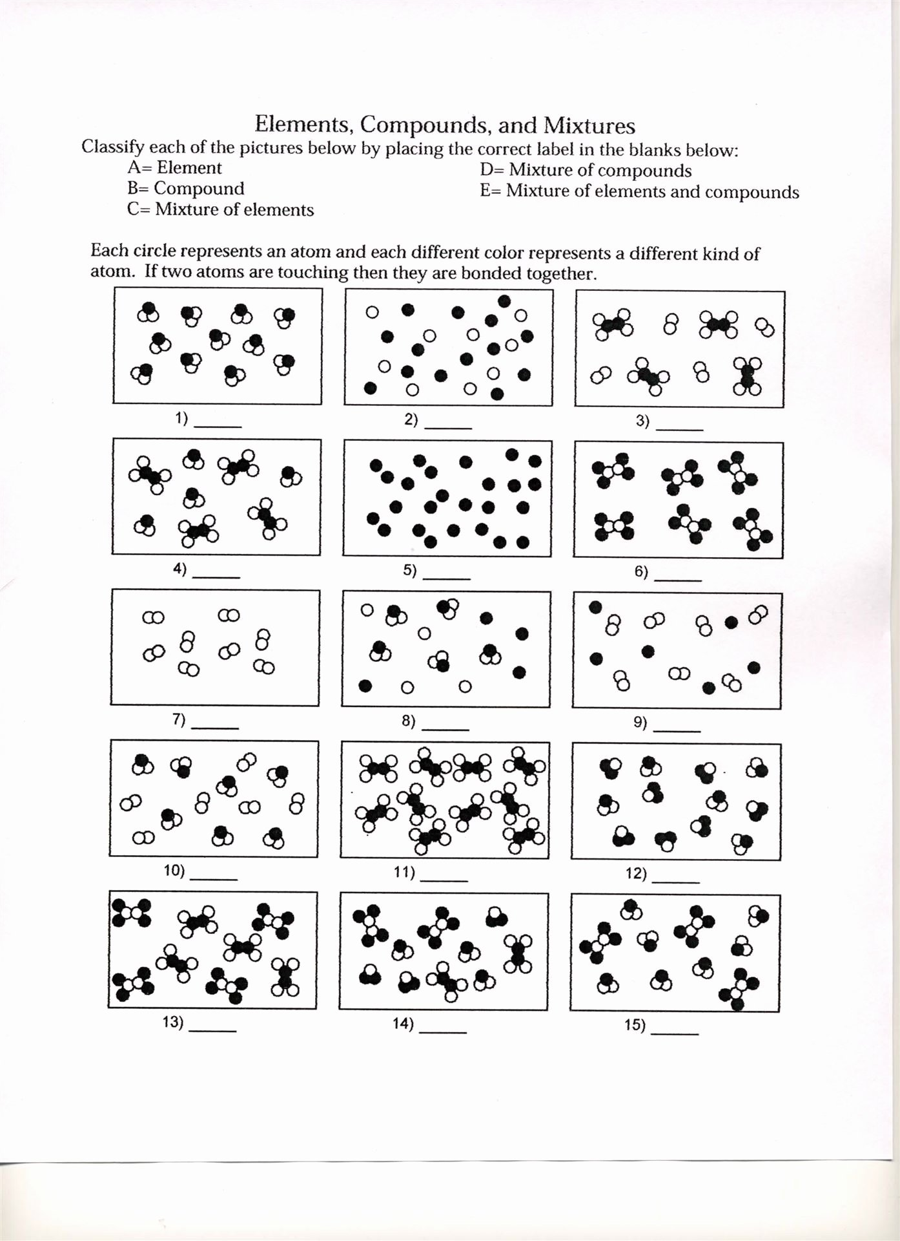

HOMEWORK -2
Please watch the following video and use this page to write the summary. Don't forget to include the chart. This will be a good review to better understand how matter can be categorized.
https://www.youtube.com/watch?v=1doJzI8qGcY

